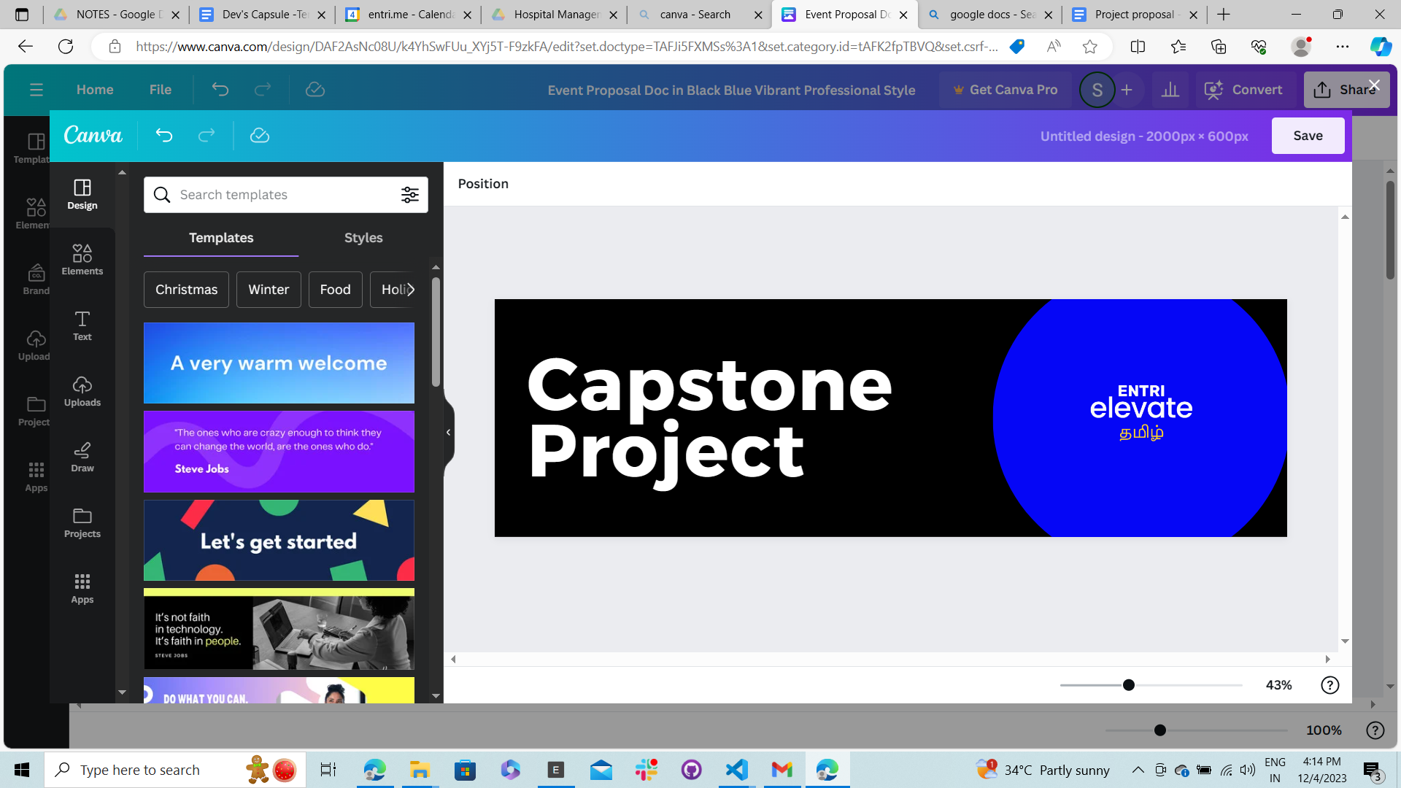

**Project Overview**

| PROJECT NAME | Turf Booking Website |
| --- | --- |
| ASSIGNED ON | 3rd Jan, 2024 |
| DURATION | 1 Month |
| CATEGORY | Full Stack Web Development |

**Project Description**

The turf booking website helps to simplify the process of reserving sports turfs by showcasing your ability to build a user-friendly platform using MERN Stack. Upon completion, you will be able to contribute to build and handle complex applications with extensive features.

**Objectives**

* The turf booking website provides a platform to reserve and pay for the use of sports fields or other outdoor activities.
* The users will be able to check out location and time availability and book for their desired turf or field. Additionally they will be able to make payments and view their booking history.
* The admin will be able to add new turf locations, setting up prices and assign managers for the specific turfs.
* The managers will be able to manage assigned turf locations and accept new bookings. Additionally they will be able to view schedules, cancel or reschedule bookings.

**Features**

* The application will be accessible in Dark and Light Theme mode.
* Only authenticated users can access the platform.
* Search Functionality (To check out available turfs and fields)
* Scheduling and Management.
* Incorporating Payment Gateway.
* Adding Reviews & Ratings.

**Future Scope**

* Extended Manager Dashboard with Specific Features for generating bills and viewing rates.
* Providing Personalized Recommendations.
* Enable Tracking of Past Bookings and Usage.
* Autogenerated Emails will be shared for every booking.

**Functional Requirement**

| TECH STACK | MERN Based JavaScript Stack |
| --- | --- |
| PROGRAMMING LANGUAGE | JavaScript |
| BUILD USER INTERFACE | HTML, CSS, Framework, React |
| BACKEND | MongoDB, Express, NodeJS |

**Timeline**

| **MILESTONE** | **DESCRIPTION** | **REVIEW DATE** |
| --- | --- | --- |
| I | Understanding Project Requirement & Design Your Database and Layout (Wireframe) | 08-Jan-2024 |
| II | Develop Server Side Logic, API Creation, Databases, Testing API | 15-Jan-2024 |
| III | Build User Interface Based on Your Wireframe and Integrate Backend using API Calls | 22-Jan-2024 |
| IV | Working With Features | 29-Jan-2024 |
| V | Testing and Deployment | 31-Jan-2024 |
| VI | Final Review (Presentation) | 02-Feb-2024 |

**References**

* JavaScript: [JavaScript | MDN (mozilla.org)](https://developer.mozilla.org/en-US/docs/Web/JavaScript)
* React: [Quick Start – React](https://react.dev/learn)
* Express: [Express 5.x - API Reference (expressjs.com)](https://expressjs.com/en/5x/api.html)
* Mongoose: [Mongoose v8.0.2: Schemas (mongoosejs.com)](https://mongoosejs.com/docs/guide.html)
* MongoDB University: [MongoDB Courses and Trainings | MongoDB University](https://learn.mongodb.com/)

**Mentor Message**

Hello Learners!  
  
Congratulations on reaching this phase in your Full Stack Development Journey.

By now, you’ve learned the core essentials required to embark your career as a MERN Stack Developer. Now it’s time to move on to the next phase which highly helps you to understand and collaborate with your team members to explore practical experience.

During this capstone project, I request you to clearly understand the project requirements and focus on the timeline with great determination. This will help you to bridge the gap between your learning and hands-on experience.

I wish you to reach out into greater heights.

Happy Coding!

**Sindhu Manivannan,  
Full Stack Mentor.**